Physics 2D

Unity 5.4+ / Unity 5.4 below

Due to some physics changes in the unity 5.4 , the asset is modified slightly. This changes are only applied when 5.4 version is used and if you are using unity below 5.4 then the basic physics is applied.

If you want more realistic physics then use unity below 5.4.

Changes Done

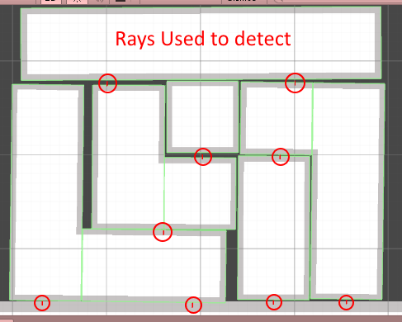

To make physics work as needed rays are used which activate and deactivate physics on the piece.

This method is only used in unity above 5.4.